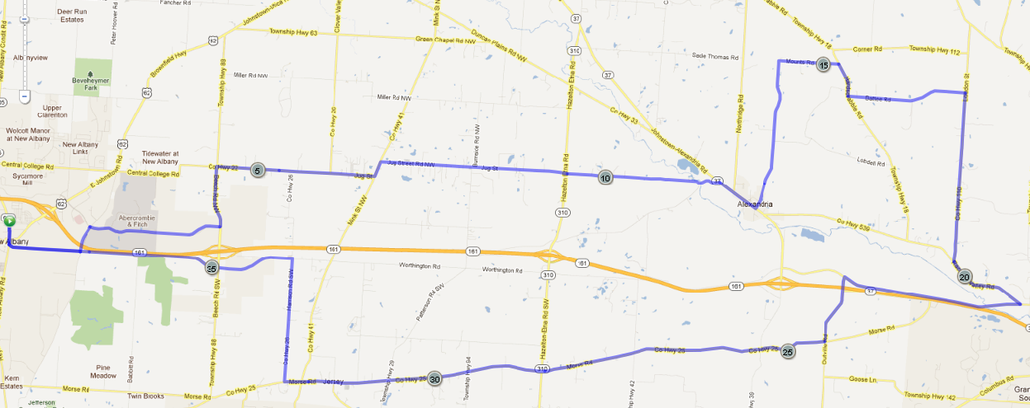
The Cycling Club COP – Week 1
A – 38 miles
B – 30 miles
C – 20 miles
Raccoon Valley
Mounts Rd
Hardscrabble
Battee Rd
Loudon St
Moots Run
Outville Rd
Old 161
Harrison Rd
Morse Rd
Smith’s Mill
Kitzmiller Rd
Beech Rd
Jug St
Jug St
Jersey Mill
20mi
38mi
30mi

